Lab 5 Computer Networks

Name: Tanvi Penumudy

Enroll No: E18CSE187

Batch: EB06

**CONTENTS:**

* Aim
* Procedure and Documentation
* Snapshots

**AIM**:

Design two separate network and connect them using Router in Cisco Packet Tracer

• Design a network-1 consisting of six end devices and Network-2 with seven end devices. Assign IP address and subnet mask to each computer connected to the network.

• Perform the configuration of the Router to connect both the networks created above.

• Establish communication between two networks by sending a PDU between source and destination computers in the networks and observe the flow of the messages.

**PROCEDURE AND DOCUMENTATION:**

* The first thing is to design two networks (with any network topography) one with six end devices and the next with seven end devices.
* The network which has been chosen by me is the star network. We need to place a switch each in the middle of the PCs respectively and connect them with a straight-through wire and assign IP addresses to both the networks.
* The IP addresses that has been assigned to the first network is in the series of 192.168.1…
* Whereas the IP addresses that has been assigned to the second network is in the series of 192.168.2…
* The latter step is to choose a router. The router chosen here is the 2911 router. The switch chosen is 2960-24TT switch.
* Then connect the switch to the router with gigabit ethernet 0/0 for the first network to the router and gigabit ethernet 0/1 to the second network to the router.
* Before that check whether both the individual networks are works by sending a PDUs form one PC to another in both the networks to ensure that both of the networks are working.
* Just ensure that both the networks are ready.
* Now Click on router and click on CLI a wizard will open
* Now follow the command to configure router, commands are given below:
* enable
* configure
* Router>
* Router(config)>
* Interface gigabitEthernet 0/0
* ipaddress 192.168.1.1 255.255.255.0
* no shut
* Do the following steps for both the sides of the network.
* For the second network you need to make minor changes like for IP address you need to type 192.168.2.1 255.55.255.0 (subnet mask) and gigabit ethernet 0/1
* Your router is now configured. Now it’s time to test.
* To test select Add simple PDU and click on one computer to another computer, if you get successful message as show in figure you had successfully configured a router and connect two different networks.

**SNAPSHOTS:**

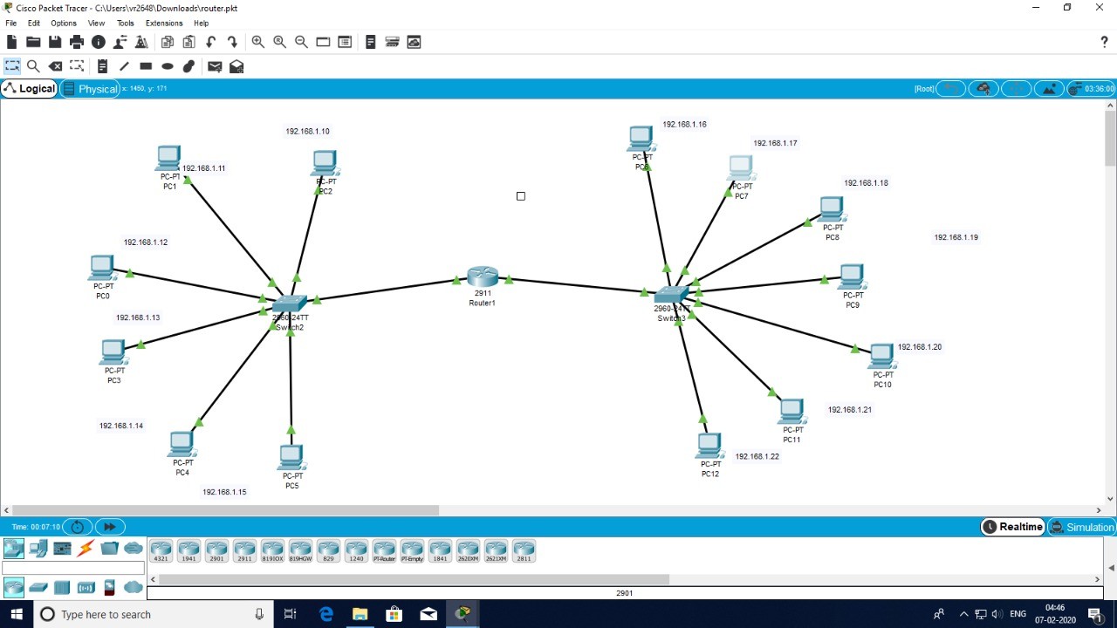

**The snapshot of the two networks and its connection via the router**

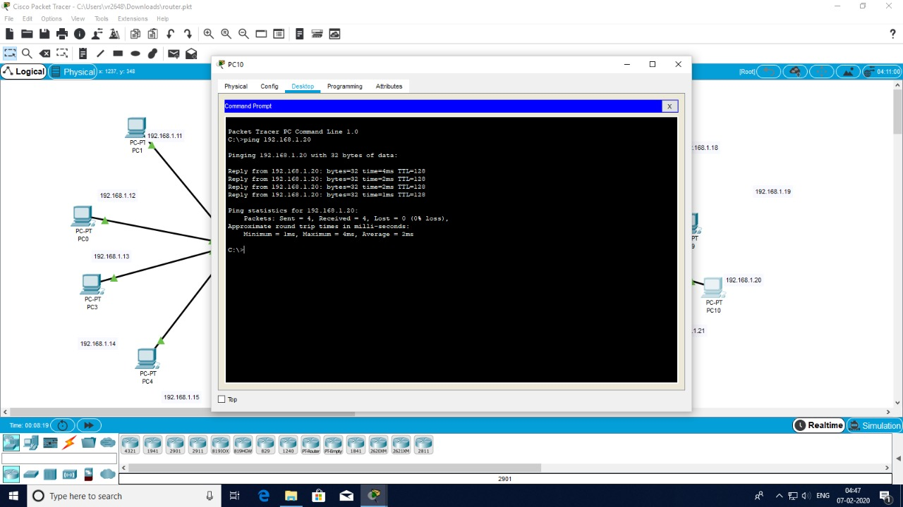

**Testing whether the message is being transmitted through the networks via the router**